Experience high-fidelity gaming audio with the gsp 500
Sennheiser’s new gaming headset combines outstanding sound and comfort

Ballerup, March 19, 2018 – Gamers want to be completely immersed in their game, where everything fades into the background and the world of the game becomes reality. For those chasing this ultimate thrill, Sennheiser has created the new GSP 500. The newest addition to the audio specialist’s acclaimed gaming range, the new open acoustic headset is so comfortable that you barely notice wearing it, while its incredibly realistic, natural sound places you at the heart of the action. With improved ergonomics, microphone performance and exceptional durability, the GSP 500 ensures a brilliantly enjoyable gaming experience.

The GSP 500 features a new, improved open speaker system designed and manufactured by Sennheiser that delivers a natural sound performance, balancing excellent clarity with an enhanced low frequency response that adds excitement to the gaming audio. Specially positioned speakers within the ear cups channel the sound directly into the ears to ensure the best possible spatial representation and awareness of the gaming environment.

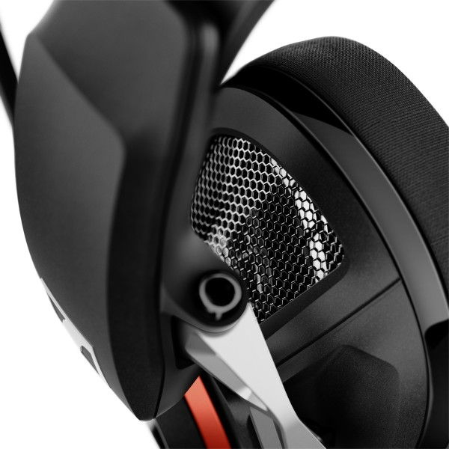 | The GSP 500 features a new, improved open speaker system designed and manufactured by Sennheiser that delivers a natural sound performance.

A perfect fit for every gamer
The new headset features a range of enhancements to ensure superior comfort - no matter your face shape or how long you play. Its advanced, 2-axis metal hinge system gives even more freedom of movement and improves the fit for a wider range of face shapes by pivoting smoothly to conform just as well to narrow or broad jawlines. The GSP 500 is also easier to customize to suit different head sizes, thanks to an innovative adjustable contact pressure mechanism integrated into the headband. This can be adjusted to ensure the headset feels perfectly snug and secure without ever feeling too tight.

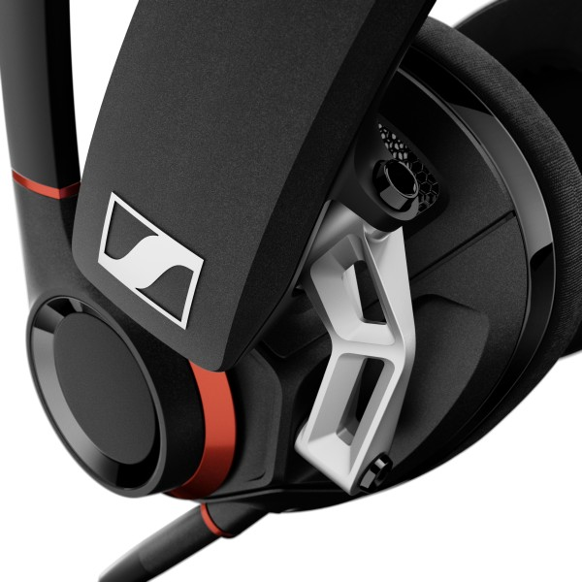 | Its advanced, 2-axis metal hinge system gives even more freedom of movement and improves the fit for a wider range of face shapes by pivoting smoothly to conform just as well to narrow or broad jawlines.

Wearing comfort is further enhanced by a more ergonomically shaped breathable ear pad design that mirrors the contours of the ear. The ear pads feature a soft fabric that has been carefully selected to provide a more pleasant, cooler feel. In addition, it’s open-back, ventilated ear cups help to keep ears comfortable and cool during long gaming sessions.

Communicate with clarity, play without distractions
“As with every Sennheiser gaming headset, the GSP 500 has been designed from the ground up to enhance every aspect of the gaming experience and let you perform at your very best,” said Andreas Jessen, Head of Product Management Gaming, Sennheiser Communications A/S. “As well as delivering superior audio and comfort, a fully immersive gaming experience also depends on effortless ease of use and communication – even in the midst of fast-paced action.”

The GSP 500 answers this need by placing every essential control immediately to hand. Its broadcast quality, noise cancelling microphone provides crystal clear communication and can be muted by simply lifting the boom arm. Similarly, adjusting game audio on the fly is made quick and easy by the volume controls integrated directly onto the ear cup.

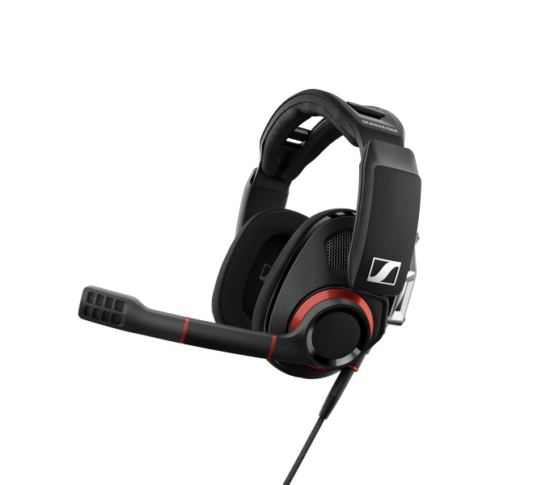 | With improved ergonomics, microphone performance and exceptional durability, the GSP 500 ensures a brilliantly enjoyable gaming experience.

The GSP 500 is multi-platform compatible for gaming with PC, Mac, as well as consoles featuring a 3.5 mm jack input. Use with lower-powered devices is improved thanks to a reduced impedance acoustic system that makes it easier to game on the go.

The GSP 500 is available from the beginning of May 2018 at the recommended retail price of 229.00€ or 229.95$. As all Sennheiser products, the GSP 500 is built to last and comes with a two-year worldwide warranty.

about Sennheiser
Sennheiser is shaping the future of audio – a vision built on more than 70 years of innovation culture, which is deeply rooted within the family-owned company. Founded in 1945, Sennheiser is one of the world’s leading manufacturers of headphones, microphones and wireless transmission systems. With 20 sales subsidiaries and long-established trading partners, the company is active in more than 50 countries and operates its own production facilities in Germany, Ireland and the USA. Sennheiser has around 2,800 employees around the world that share a passion for audio excellence. Since 2013, Sennheiser has been managed by Daniel Sennheiser and Dr. Andreas Sennheiser, the third generation of the family to run the company. As part of the Sennheiser Group, the joint venture Sennheiser Communications A/S is specialized in wireless and wired headsets and speakerphones for contact centers, offices and Unified Communications environments as well as headsets for gaming and mobile devices. In 2016, the Sennheiser Group had sales totaling €658.4 million. www.sennheiser.com

Global Press Contact

Anna Bornemann
Sennheiser Communication A/S
Head of Marketing, Gaming
T: +45 5618 0323
abor@senncom.com

